**KLM Assignment**

The coding part has been done for the API which is having the below requirement:

The data will automatically load on the h2 database(inbuilt with Spring boot) from the csv file.



Please find the result for the given scenario 1:

When the year alone has been given, then the api should return the list of average close values of each month:

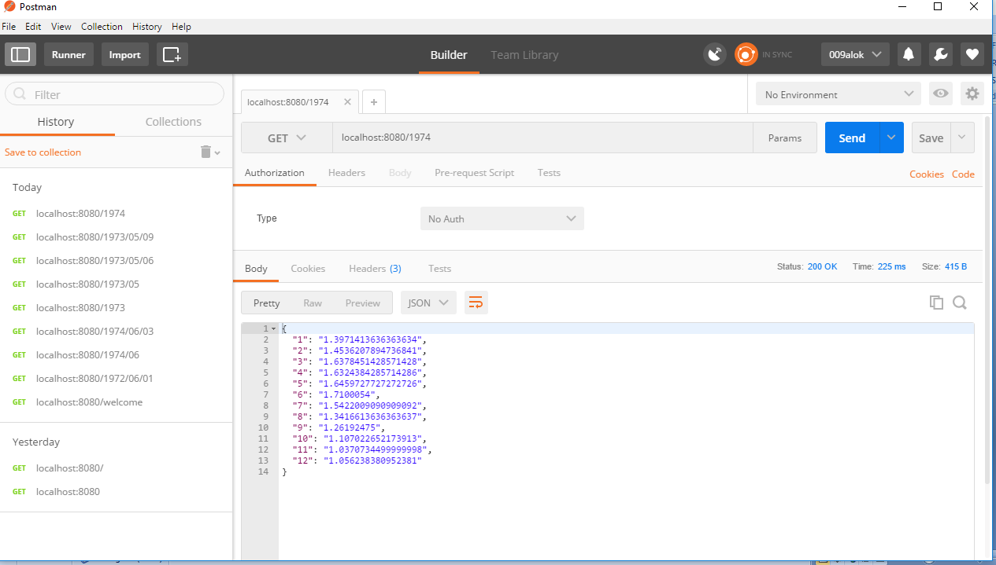

Please find the result for the given scenario 2:

When the year and month has given then the api should return the list of close value of each day of that respective month:

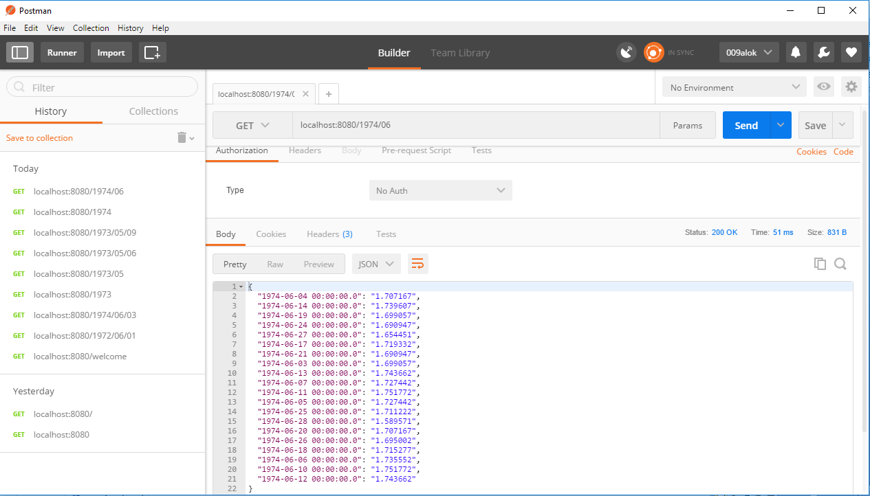

Please find the result for the given scenario 3:

When the year, month and date has been given then api should return the closing value of that particular day:

